**Being a Countertenor (name still in progress)**

**Project Purpose**

The purpose of this web site is to inform an audience, from a musical stand point, exact what is a countertenor. It will provide a little biography of how I realized I was one and will provide other famous countertenors of this era. Another page will describe the origins of countertenors and why it was so popular a voice type.

**The Audience**

The audience will be all people of any age and gender. In particular, the audience will be those who are curious of their voice type or a background of this particular voice type. Average age would be 30s, due to voice teachers trying to help their students.

**Web Pages**

* About Me
  + Brief biography on my life as a singer and my role in the singing community.
  + Photo of myself singing.
  + Opportunities I have had specifically as a countertenor
* About Countertenors
  + What is a countertenor?
  + When was the common era for countertenors?
  + Why was there a need for them?
  + Is there still a need for them?
* Famous Countertenors
  + A list of famous countertenors around the world.
  + An extremely brief detail of each singer.
* Music Repertoire
  + What era is the most accessible to voice fitting songs?
  + Why that era?
  + Songs that have been sung by myself.
  + Songs that have been sung by other countertenors.
* Opportunities to perform
  + A list of groups that are taking countertenors.
  + Operas that are going on right now that cast countertenor roles, if applicable.

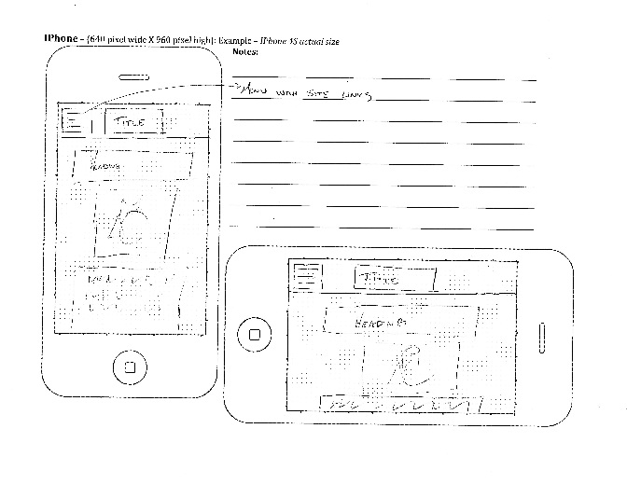**Wireframe Sketches**

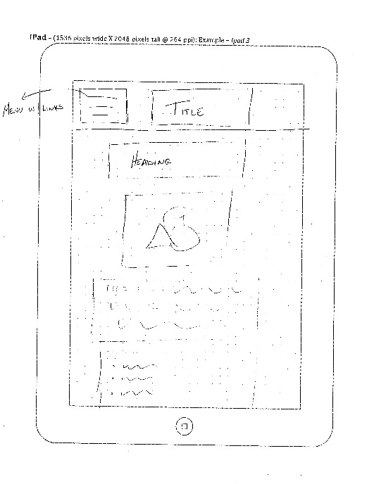

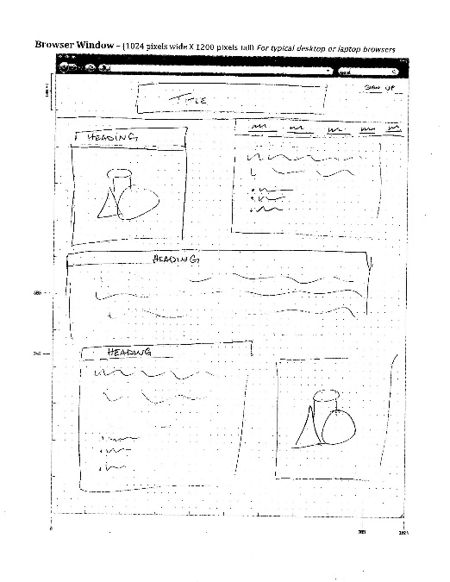

**Usability Concepts**

Some of the concepts I plan on taking care of are:

* I will have my font size at minimum 16pt. Other fonts will be bigger on the basis of importance.
* My image ALT tags will be very simple and understandable if the image does not show up.
* My links will be consistent in the manner of their placement on each page and will be understandable
* My headings per section will be a very simple description of the information that they would be looking for.
* My copy will be short, simple, and to the point. It will be in a manner that they will find the information they are looking for and be able to take away that content.